Atomic Structure

The Atom (The atomic theory):

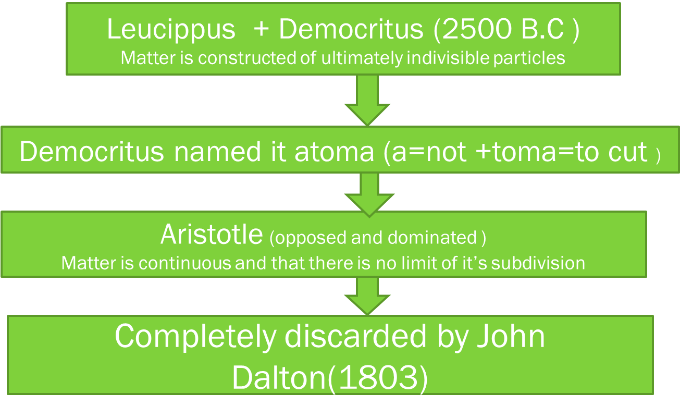

Dalton’s Atomic Theory(Atom=can not be cut =indivisible)

(i). Every matter is constructed by small particles called atom.
(ii). The properties and masses of particles in the same matter is similar.
(iii). The properties and masses of various particles in the various matters are different.
(iv). Atoms are indivisible and have no losses.
(v). Combining two or more atoms from new matter and this combination occurs according to specific ratios.
(vi). Only atoms can contribute in a chemical reaction.
(vii). There has no losses or reproduce of atoms by a chemical reactions. Only change it’s state or appearance.

Limitations/Defects /Drawbacks of Dalton’s Atomic Theory
(i). Atoms are divisible.
(ii). Atoms of same matter may differs in masses (Isotop).
(iii.) Atoms of different matter may same in masses (Isobar).

Ques(01). Define nuclear charge and effective nuclear charge.

Ques(02). Define atomic number.

Nuclear Charge:( Atoms as carriers of electricity)

Atoms act as carriers of electricity when an electric current is passed through a salt solution. Faraday discovered that the equivalent weights of different substances were liberated at the electrodes by the passage of the same quantity of electricity.
The nuclear charge is the total charge of all the Protons in the nucleus.
It has the same value as the atomic number.

Effective Nuclear Charge
Effective nuclear charge is the charge felt by the valence electrons after we have taken into account the number of shielding electrons that surround the nucleus.

Atomic Number:
The total number of unit positive charges on the nucleus is called the atomic number of the element.
Atomic number of an element is defined as the number of unit positive charges in the nucleus of the atom of that element or as the number of protons present in the nucleus.

Atomic number(Z) =no. of unit positive charges in the nucleus(nuclear charge)
=no. of protons in the nucleus(P).
=no. of electrons revolving in orbits(e-)

The serial number of elements of it’s position in the periodic table starting from hydrogen(H) as the first element.

Ques(03). Explain the Rutherford’s ∞-particle Scattering Experment (Discovery of nucleus).

Rutherford’s ∞-particle Scattering Experment(Discovery of nucleus):
In order to testThomson’s model and to know as to how and where the electrons are located in the atom, Rutherford (1911) , a British scientist, performed some experiments on the scattering of ∝-particles by a thin metal foil.
Here, it may be mentioned that ∝-particle is a helium nucleus (⁴₂He²⁺), which consists of two units of positive charges and it’s mass number is equal to 4.
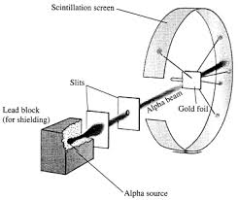
Fig(i). Pictorial representation of Rutherford’s ∞-particle Scattering Experment.

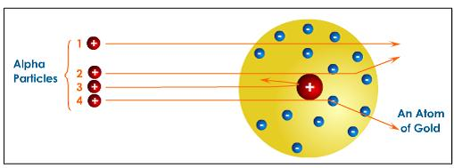
Fig(ii). Three types of deflection of ∞-particles by a thin metal foil shown in a simple way.

Rutherford observed that most of the ∞-particles passed through the foil without any deflection from their path and struck the screen at it’scentre, causing illuminations. A few of them were deflected at some angles (90° or wide angle) after passing through the foil.

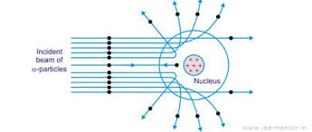

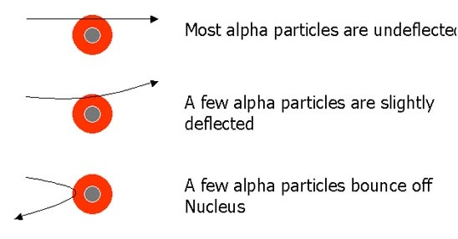

Fig(iii). Three types of deflection of ∞-particles by a thin metal foil shown in a simple way.
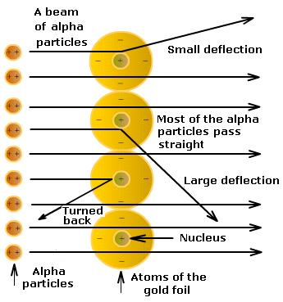

Very few (not more than one in 10,000 ) turned back on their original path. All the three types of deflections are shown in Fig(ii).

Ques(04). Write down the postulates of the Rutherford’s ∞-particle Scattering Experment (Discovery of nucleus).

Ques(05). Write down success and drawback of Rutherford’s Nuclear Model of Atoms.

Rutherford’s Nuclear Model of Atoms:
Rutherford (1911), a British scientist, performed some experiments on the scattering of ∝-particles by a thin metal foil. Here, it may be mentioned that ∝-particle is a helium nucleus which consists of two units of positive charge and it’s mass number is equal to 4. Hence it is represented by the symbol (⁴₂He²⁺)

Postulates of this model:
(i). Atoms contains a massive (heavy) and positively charged part at it’scentre. This central part of the atom is called nucleus.
(ii). The volumeoccupaied by the nucleus is only a minute fraction of the total volume of the atom.
(iii). Atom is not all solid, as was earlier suggested by Dalton, but is extraordinarily hollow,since it consists of a lot of empty space round the nucleus.
(iv). Electron are revolving round the nucleus in closed orbits with a fast speed and hence almost all the space round the nucleus is occupied by the revolving electrons.

Success of Rutherford’s Atomic Model:
(i). Could explain the ∞-particle scattering experiment.
(i). Could explain the presence of nucleus.
(ii). Could explain that atom is neutral in charge.

Defects/Drawbacks/Limitations 0f Rutherford’s Atomic Model:
(i). Compared as solar system atom model, but have attraction and repulsion.
(ii). According to Max-Plank’s Quantum Theory, if a charged particle rotate round the another charged particle then it will emit radiation gradually and come nearer to the centre.
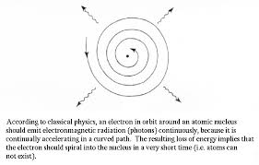
(iii). Can not explain the continuous spectrum of Radiation.
(iv). Can notexplain the shape and size of Orbials.
(v). Can not explain the mode of rotation for multi-electron orbitals.

Ques(06). Write down success and drawback of Rutherford’s Nuclear Model of Atoms.

Ques(07). Write down success and drawback of Rutherford’s Nuclear Model of Atoms.

Bohr’s Atomic Model (1913):
(i). Every atom has 2 parts :- (a) central positive (+Ve) part (=Nucleus).
(b) outernegative (─Ve) part (= Shell / Electrons).
(ii). Specific orbitals at specific distance/radius.
(iii). Angular momentum of electron(e⁻) during the rotation surrounding the nucleus is $\frac{h}{2}$ or it’s multiples. (i.e., n.$\frac{h}{2}$where, n= 1, 2, 3, …..)
(iv). For a particular orbit electron does not emit/absorb energy.
(v). Emition spectrum :- Higher→ Lower
Absorption spectrum ;- Lower→ Higher
(vi). Energy for emission/absorption, ∆E=E₂─E₁ =hv

Success of Bohr’s Atomic Model: (Got Nobel prize in 1922)
(i).Able to explain the stability of atoms.
(ii).Became able to explain hydrogen Spectrum.
(iii). Became able to calculate the wave-length.
(iv). Became able to calculate the radius of orbit.

Defects/Drawbacks/Limitations of Bohr’s Atomic Model:
(i). Can not explain the mode of rotation of multi-electron orbitals.
(ii).Why various discrete rays occur instead of continuous spectrum.
(iii).Does not matches with the theory of relativity.
(iv).Unable to explain the wave nature of emission spectrum.

Ques(08). Write down the difference between Rutherford’s and Bohr’s atomic model.
Difference between Rutherford’s and Bohr’s Atomic Model:
Rutherford’s Atomic Model | Bohr’s Atomic Model
1.Based on Max-Well’s Electromagnetic theory. | 1.Based on Max-Plank’s Quantum theory.
2.Unable to explain Emission/absorption . | 2.Able.
3. Not express shape and size of orbitals. | 3. Express
4. Can not calculate hydrogen spectrum and wave-length. | 4. Can be calculated.
5. Have no stability of atom. | 5. Have stability

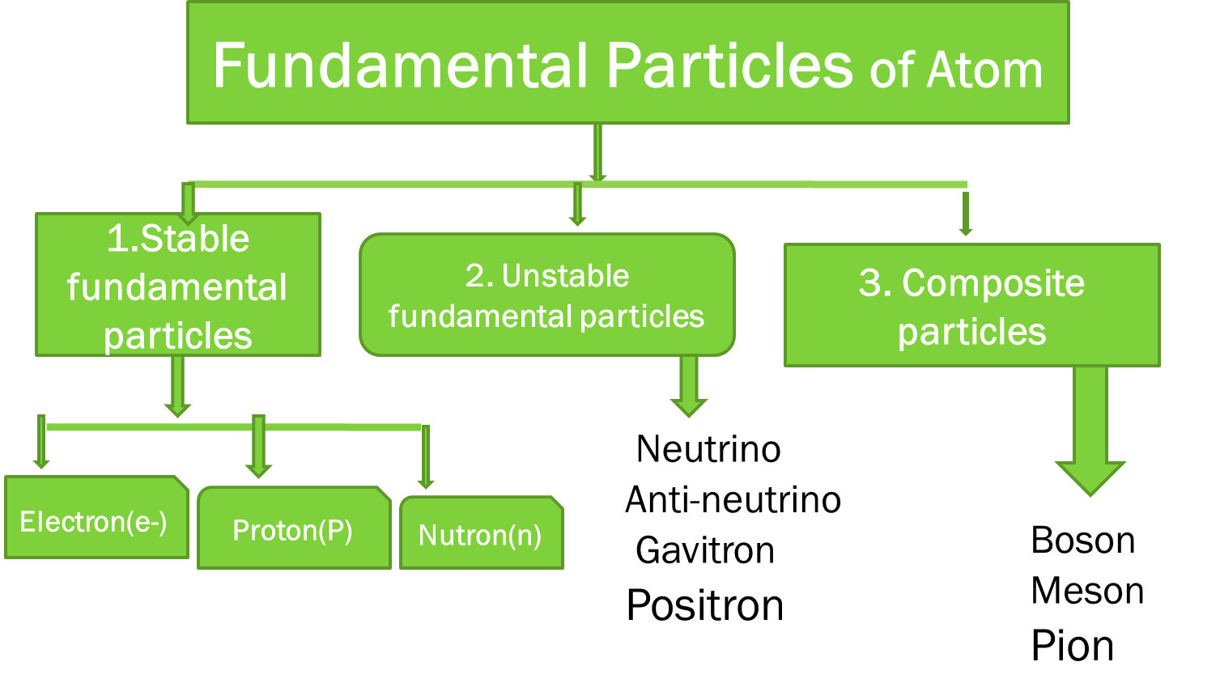
Ques(09). Discuss about the fundamental particles of atom.

 | Electron (e-) | Proton (P) | Neutron (n)
1.Discoverer | J.J. Thomson(1897) | Rutherford (1919) | Chadwick (1932)
2. Symbol | e- | H+ / P | n
3. Position | Outside nucleus/shell | Inside nucleus | Inside nucleus
4. Charge | ─1.6×10 ^-19 C | +1.6×10^ -19 C | 0
5. Mass | 9.11 ×10^ -28 gm | 1.673×10 ^-24 gm | 1.675×10^ -24 gm

Ques(10). Discuss/Define the following terms with suitable examples:
(i). Isotope
(ii). Isobar
(iii). Isotone
(iv). Iso electronic

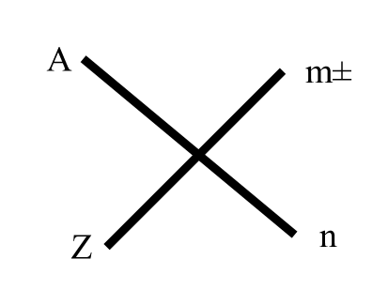Here, ±m = no. of charges remain of that atom
n = no. of atoms present in the molecule
Z = no. of protons (Atomic number) = P
A = Mass no. = no. of proton + no. of neutron

(i). Isotope: Different atoms of same element which have same number of proton (P) , but due to having different number of neutron (n), mass number become different, these are called isotop with each other.

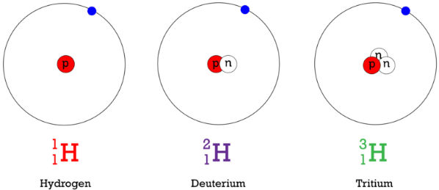
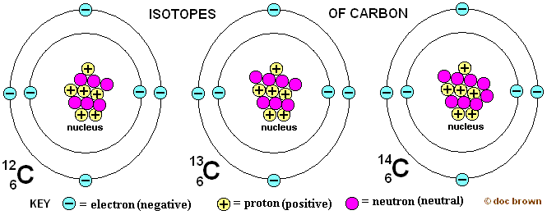

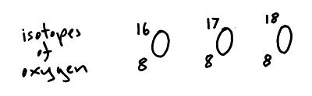

(ii). Isobar: Different atoms of different elements which have different number of proton (P) and neutron (n) , but mass numbers are equal/same, these are called isobar with each other. Exam: ¹⁴₆C , ¹⁴₇N
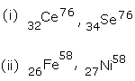
(iii).Isotone: Different atoms of different elements which have same number of neutron (n), but due to having different number of proton (P), mass number become different, these are called isotop with each other.
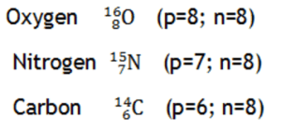
(iv). Iso electronic: Different ions of different elements which have same number of electrons(e⁻) are called iso electronic with each other.
Exam:
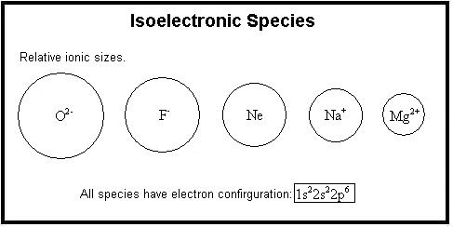

Ques (11 ). Why Na⁺ or K⁺ is charged but Na or K is neutral in charge ?

Ques(12). What do mean by spectrum? Write down the classification of spectrum.

Spectrum:
A spectrum is any array of waves or particles which is spread out according to the increasing / decreasing of some properties such as wave-length or frequency.
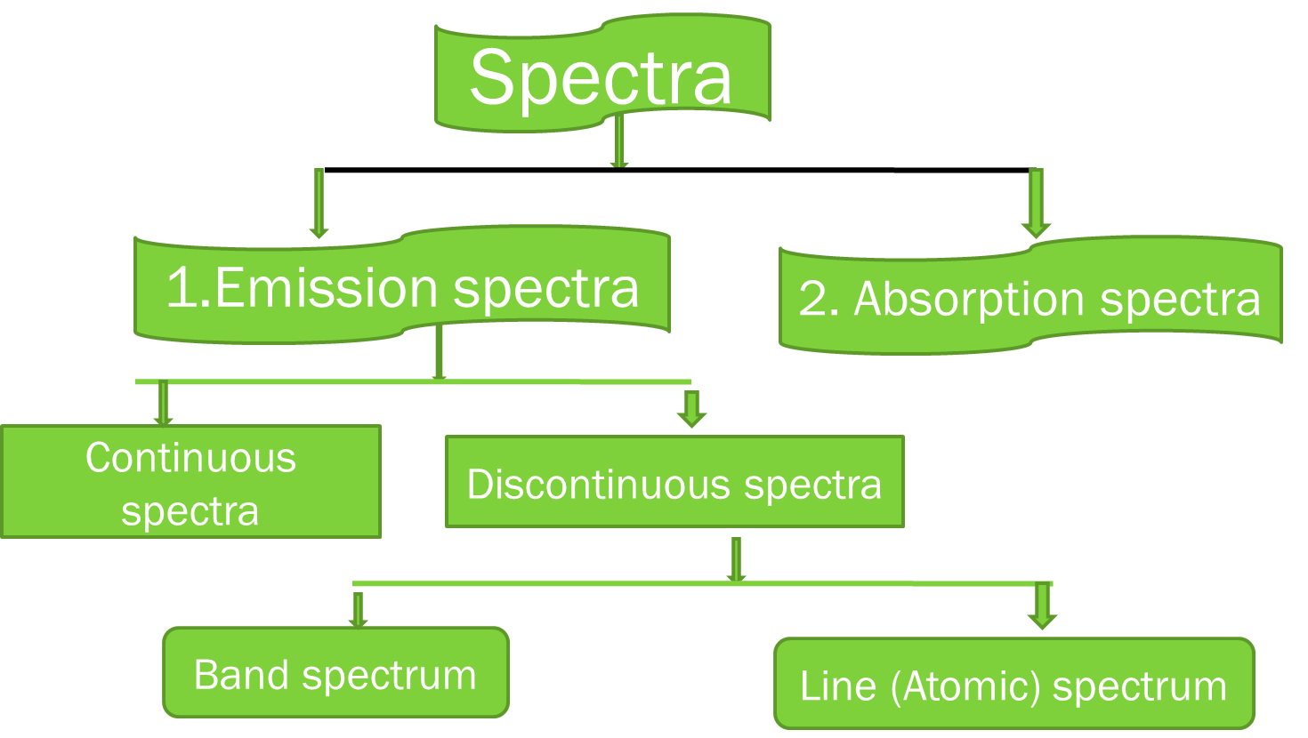

Line spectrum / Atomic spectrum:
When an atom of an element ,whether free or in combined state , absorb energy and gets excited . The excited atom emits light radiations of a characteristic colour. When this emitted radiation is allowed to pass through a prism , it is resolved into individual components. The patern of differeent components of the radiation is called line / atomic spectrum.
Exam: Na-spectrum , H- spectrum , etc.

Ques(13). What do mean by Line/Atomic spectrum and hydrogen spectrum?

Hydrogen Spectrum:
When an electric discharge is passed through hydrogen , the molecules of hydrogen break into atoms. These atoms absorb energy from the electric spark and get excited. The excited atoms give the extra energy in the form of emitted light (bluish light ).
When this emitted light is allowed to pass through a prism , line spectrum of hydrogen is obtained . This spectrum is called emission hydrogen spectrum.
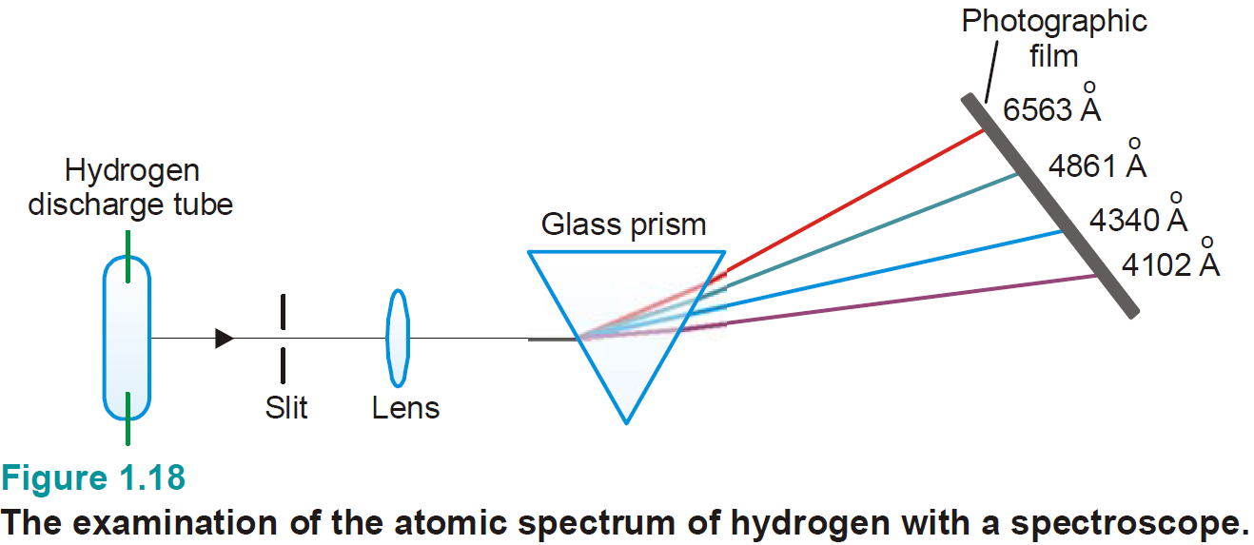

Ques( 14). How hydrogen spectrum is obtained ?

Ques( 15). Classify spectral line.

Ques(16). How Lymen series, Balmer series, Paschen series, Brackett series and Pfund series are Obtained ?

Ques(17). How the 2nd ray of Lymen series or 3rd ray of Paschen series is Obtained ?

Ques(18). Calculate the frequency of wave number, energy, wave-length of the 2nd ray of Balmer series or 4th ray of Lymen series.

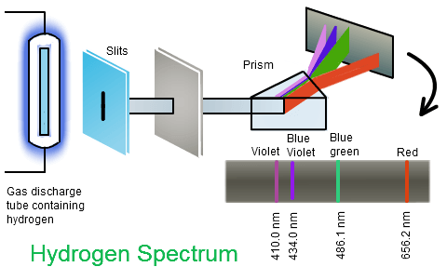

Classification of Spectral Lines:
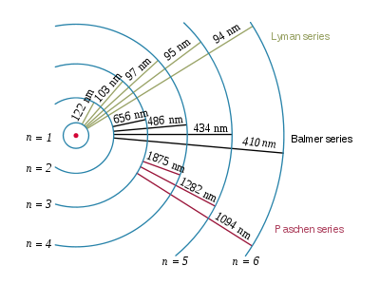
Spectral lines in hydrogen spectrum can be classified into five (5) groups or series, called spectral series which are named after the names of their discoverers as below:
(i). Lymen series
(ii). Balmer series
(iii). Paschen series
(iv). Brackett series
(v). Pfund series

According to Bohr’s atomic model, electrons jumps from lower energy level to higher energy level by absorbing energy and come back from higher energy level to lower energy level by emitting equal amount of energy which was absorbed. From that emission we get various spectral lines.

(i). Lymenseries : n₁ = 1 , n₂ = 2 , 3 , 4 , 5 ,…………………….

(ii). Balmerseries : n₁ = 2 , n₂ = 3,4,5,6 ,……………………

(iii). Paschenseries : n₁ = 3 , n₂ = 4,5,6,7,……………………

(iv). Brackett series : n₁ = 4 , n₂ = 5,6,7,8,…………..

(v). Pfundseries : n₁ = 5 , n₂ = 6,7,8,………….
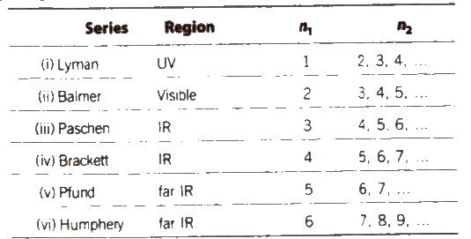

We can calculate the wave-number of various spectral series of hydrogen spectrum from Bohr’s atomic model by the following equation.
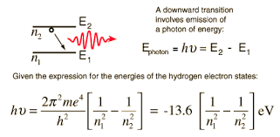
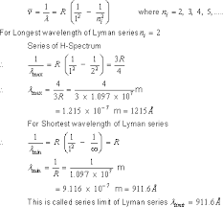
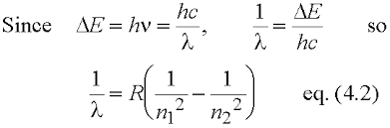
Ques(19). What is quantum ? Explain the Plank’s quantum theory of radiation.

Quantum:
A quantum is the smallest unit of waves in the form of which a hot body emits radiant energy and which can exist independently.

Plank’s Quantum Theory of Radiation:
The energy (E) asssociated with each quantum / photon (in case of light ) of a given radiation / light is proportional to the frequency (v) of the emitted radiation / light.
E∞ v or, E=hv
Where, h= Plank’s constant = 6.63×10^-34 J-S
E= Energy associated with each quantum / photon of a given radiation .
v= Frequency of the emitted radiation of light.
This equation is called Plank’s equation .

Application of Plank’s Quantum Theory of Radiation:
(i). In 1905 , Einstein applied this theory to explain the photo-electric effect.
(ii). In 1913 , Bohr used this theory to explain the structure of the atom and origin of spectral lines seen in hydrogen spectrum.
(iii). In 1922 , Compton applied this theory to explain the phenomenon of incoherent scattering of X-rays .

Some problems
Prob(01). Calculate the energy of a photon of light of frequency of 3×1015 s^{–1}
Prob(02). Two lines one violet and the other red , in a spectrum have wave-lengths equal to 4000 A˚ and 6000 A˚ respectively . Calculate the energy of photons transmitted by them .

Prob(03). Calculate the energy in KJ / mole associated with a radio wave of wave-length equal to 3×1013 A˚.

Prob(04). Calculate the energy , frequency , wave-number of a light with the wave-length of 4000 A˚.

Quantum Number:
The identification numbers or labels which completely define the electron in an atom ,i.e , these numbers –
(i). Specify the position (location) of an electron in an atom,
(ii). Predict the direction of spin /self-rotation of the electron and
(iii). Determine the energy and angular-momentum of the electron -is called quantum number.

Four(4) quantum numbers which are required to completely specify the character of the electron are:-

1. Principal quantum number (n)→ size
2. Azimuthal / subsidery quantum number(l)→ shape
3. Magnetic quantum number(m) → orientation /dimensional position
4. Spin quantum number(s) → mode of rotation

Each quantum number refers to a particular character of an electron in an atom. Now, let us discuss the quantum numbers one by one.

(1). Principal Quantum Number (n) :
Bohr had assumed that electron in an atom are revolving round the nucleus in circular orbits/shells which he had also called energy levels.
Different energy levels in an atom have been represented by “n”, which can have non-zero positive integer (whole number) values upto infinity.

i.e., n= 1, 2, 3, 4,5, … …… …. , ∞



n=1 (first shell) → K → 2.1² = 2
n=2 (second shell) → L → 2.2² = 8
n=3 (third shell ) → M → 2.3² = 18
n=4 (fourth shell ) → N → 2.4² = 32

n=1 < 2 < 3 < 4
K < L < M < N
E₁ < E₂ < E₃ < E₄

(2). Azimuthal or Subsidary Quantum Number (l) :
The appearance of sevaral lines in a single line has been explained by saying that each shells divided into sub-shells which give closely spaced line in the spectrum.

In order to represent these sub-shells only one quantum number namely- principal quantum number(n) is not sufficient .
Ruther , another quantum number (l) is used to represent the sub-shells of which the shells are composed .

The value of “l” depends on the value of “n”. For a given value of “n”, “l” can have the values from 0 to (n−1).

l = 0 → (n─1)
i.e., l= 0,1, 2, 3, 4, ……………………… (n ─2), (n ─1)

Sub-shell = not orbital.
Shape of subshell=position of e⁻ in specific subshell of a shell.
According to Somarfield → e⁻ revolves round the elliptical sub- shell in a circular orbit .
Maximum e- retaining power = 2.(2l + 1)

(3). Magnetic Quantum Number (m):
In order to represent these orbitals the first two quantumnumbers namely principle quantum (n) and azimuthal quantum number (l) are not sufficient. Ruther, a third quantum number namely Magnetic Quantum Number (m) is used to represent the orbitals of which a given sub-shell is composed .

“m” can have integral values ranging from ─ l through 0 to + l
i.e., m = 0,±1, ±2, ±3, ±4,………………, ±l

Consequent,
when , l = o (S─sub-shell) , m = 0
when , l = 1 (P─sub-shell), m = ─ 1 , 0 , +1
when , l = 2 (d─sub-shell) , m = ─2 , ─1 , 0 ,+1 ,+ 2
when , l =3 (f─sub-shell) , m = ─3,─ 2, ─1, 0,+1,+2,+3

m = Orientation / dimensional position = Orbital .
Total possible no. of orbitals = 2l+1

(4). Spin Quantum Number (s) :
An electron while moving in an orbit round the nucleus, also rotate or spins about it’s own axis (self - rotation) either in a clock-wise direction or in an anti-clock wise direction.

In order to represent the direction of the spin or self- rotation of an electron about it’s own axis , we use a quantum number which is called spin quantum number (s).

Spin quantum number can have 2 values namely, +$\frac{1}{2}$ and ─ $\frac{1}{2}$

An electron spinning in a clock-wise direction is represented by an arrow pointing upward (↑) , while that spinning in an anti-clock wise direction is represented by an arrow pointing downward (↓).

Summary

(1). Principal Quantum Number (n): Bohr → n= 1, 2, 3, 4, ……………..,∞
Main energy shell = size of orbit
Maximum e⁻ retain=2n²

(2).Azimuthal/Subsidary Quantum Number (l): Sommerfield, l= 0 → (n─1)
Shape of sub-shell
Maximum e⁻ retain= 2(2l+1)
(3). Magnetic Quantum Number (m): Zemann, m= (─) l → 0 → (+)l
Orientation/dimensional position
Number of orbital in a sub-shell=(2l+1)

(4). Spin quantum Number (s): Gouldsmit and Uhlenbeck,
s=m(+1/2 , ─1/2)
Mode and direction of spin of e⁻

Ques(20). Write down the differences between Orbit and Orbital.

Difference between Orbit and Orbital:
Orbit | Orbital
(1). Bohr’s postulate→”An orbit is a definite circular path at a definite distance from the nucleus in which the electron revolves round the nucleus. | (1). Zeeman→ orbital is defined as a 3 dimensional region/space around the nucleus within which the probability of finding of electron(e-) with a certain energy is maximum.
(2). Designated by “n”. n=1,2,3,……..  K, L, M, N, ... | (2). Designated by s , p , d, f .
(3) Exact position/location of electron(e⁻). | (3). Not specify the exact position/location of e⁻
(4). Planar motion of e⁻ | (4). Three-dimensional motion of e-.
(5Max. no. of e-=2n² | (5) Max. no. of e⁻ =2
(6). Circular in shape. | (6). Different shapes. Ex: s=spherically symmetrical,  p=dumb-bell.

Problems Based on Quantum Number
Ques(21). Give the values of all quantum numbers for the electron having highest/lowest energy of a Na/K-atom when it is in ground /excited state.

Ques(22). Difference between “2P” and “3P” orbitals.

Ques(23). With suitable explanation point out the forbidden designation from the following atomic orbitals:-7S , 2d , 4P , 3f , 4S , 5P .

Ques(24). Explain why orbitals like “1P”,“2d”and“3f ”are not possible ?

Ques(25). Calculate and identifyall the indiidual orbitals for- (¡) n=3 , (¡¡) n=4
Ques(26). Which sets of quantum number are not permissible and why ?
(¡) n=5 , l=4 , m=0 , s=+1/2 ; (¡¡) n=3 , l=0 , m= ─1 , s= ─1/2
(¡¡¡) n=3 , l=1 , m=2 , s=+1/2; (¡v) n=2 , l=2 , m=0 , s=+1/2
(v) n=2, l=2, m= ─1, s= ─1/2 ; (v¡) n=2 , l=1 , m=+1, s= ─1/2
(v¡¡)n=3, l=2, m=+1, s=0.

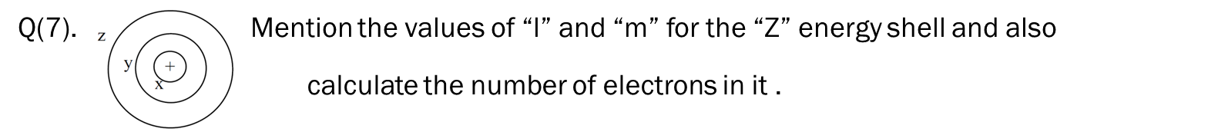

Ques(28). How the maximum number of electron(e-) retained be calculated in various sub-shell ?

Ques(29). Determine the no. of orbitals and total no. of electrons in M-shell from the calculation of “l” and “m” .

Ques(30). Give the values of all quantum numbers for the outermost electron and last electron of Cu / Zn atom.

Electronic Configuration of atoms:

At normal state , generally atoms are nutral in state because of having equal no. of positive(+) proton and negative(─) electrons.

According to quantum Mechanics, electrons are revolving around the nucleus in specific orbitals. The specific arrangement of e- in specific orbitals is called electronic configuration.

3 major rules for the electronic configurations of atoms are-
(1). Auf-bau Principle,
(2). Pauli’s Exclusion Principle,
(3). Hund’s Rule.

Ques(31). What is (n + l) rule? Illustrate your answer bywriting the electronic configuration/distribution of potassium atom.

Ques(32). Whythe19th electron ofK atomenter in 4s instead of 3d ?

(1). Auf-bau Principle /(n+l) rule: (Auf-bau = Building up)
(i). The relative order of energy of different orbitals (or, the sequence in which various orbitals are filled up with electrons) can also be determined with the help of (n+l) value for a given orbital (n=principle quantum number , l= azimuthal quantum number).

This rule is called (n + l) rule. According to this rule, the orbital having the lowest value of (n+l) has the lowest energy and hence is filled up first with electrons.
1s<2s<2p<3s<3p<4s<3d<4p<5s<4d<5p<6s<4f<5d<6p<7s<5f<6d<7p<8s.

(ii). When two/more orbitals have the same value of (n+l) ,the orbital with lower value of “n” is lower in energy and hence is filled up first with electrons. Thus the order of energies of,for example, 3d, 4pand 5s orbitals for all of which (n + l) = 5is as-
3d (n =3) < 4p (n=4) < 5s (n=5)

Since, “n” for these orbitals are 3,4 and 5 respectively. Thus, orbitals will be flled up with electrons in the following sequence:

3d → 4p → 5s (Orbitals being filled)

Similarly, 4f → 5d → 6p →7s

Ques(33). For the 1st and last electron of Na-atom , explain the Pauli’s exclusion principle.

Ques(34). For the 1st two electrons or last two electrons of K-atom , explain the Pauli’s exclusion principle.

(2). Pauli’s Exclusion Principle:
“It is impossible for any two electrons in the same atom two have their four quantum numbers identical”

In the same orbital of an atom two electron can have 3 quantum identical at the most, but the fourth quantum numbers identical at the most .

Explanation/Illustration:
Let us consider helium(He) atom which has 2 electrons (atomic number = 2) is “1s” orbital for which –
n=1 , l=0 and m=0. The fourth quantum number for the two electrons in 1st orbital are as follows:

Electron number | Quantum numbers  n l m s | Set of values of quantum numbers (n , l , m , s )
1_{st} electron (↑) | 1 0 0 +1/2 | (1 , 0 , 0 , +1/2 )
2_{nd} electron (↓) | 1 0 0 ─1/2 | (1 , 0 , 0 , ─1/2)

(3). Hund’s Rule of Maximum Multiplicity :
The distribution of electrons in a set of degenerate orbitals like P_{x} , P_{y} , P_{z} set; d_{xy} , d_{yz} , d_{zx} , d_{x2 ─ y2} , d_{z2} set etc., of a given sub-shell takes place in such a way as to give the maximum numbers of unpaired electrons and these electros must have the same direction of their spins.
As for example , electronic configuration of “N” is
N₍₇₎ → 1s² .2s².2p³
Actually, 2p orbital have 3 equal energetic orbitals, which are denoted as P_{x}, P_{y}, P_{z}.
So, in case of “N” above 3 electrons are occupied separately and their spins will be in equidirections.

Such as , N→ 1s².2s². 2P_{x}¹.2P_{y}¹. 2P_{z}¹
This configuration may be displayed as follows:

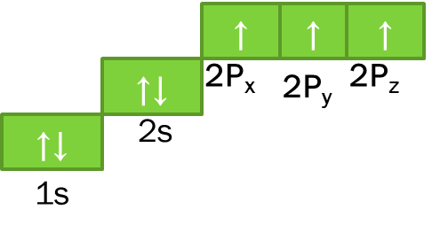
Here, the arrow (↑) indicates the spins of electrons.

Ques(35). Why it become 4s¹ instead of 4s² in case of the electronic configuration of Cu-atom ?

Ques(36). According to Hund’s rule, write the electronic configuration of Fe²⁺ and Cr.

Ques(37). For the 1st two electrons or last two electrons or 1st and last electrons or 1st and 5th electrons or 10th and 15th electrons of Na-atom /K-atom /Ca-atom , explain the Pauli’s Exclusion principle.

